

Software Engineering Department  
 ORT Braude College

Capstone Project Phase A – 61998

**WeatherGuide - An Application For Long-range Weather Forecasting Project**

**Authors:**

Foze Abo Zhaya – Foze.a.z177@gmail.com

Jasmen Mura – Jasmenmura@e.braude.ac.il

**Supervisor:**

Dr. Zakharia Frenkel

**24-2-D-32**

**Table Of Contents**

Abstract

1. Introduction

2. Related Work

2.2 Existing Applications for Long-Range Weather Forecasting

2.2.1 The Weather Channel:

2.2.2 Weather25:

2.2.3 WeatherStack

How Our App is Different

3. Expected Achievements

4. Engineering Process

4.1 Process Description and Explanation

4.2 Motivation and Rationale for Our Approach

Work Steps and Rationale

4.3 Constraints Affecting Our Development Process

5. Product

5.1 Algorithms Used

How We Use It in Our Algorithm in the Project:

Why It’s Useful for Our Weather Forecasting Project:

5.2 Models Developed

5.3 Requirements

Table 5.4.1 - System Functionalities:

Table 5.4.2 - User Interaction Functionalities:

5.5 Diagrams

5.5.1 Use Case Diagram

5.5.2 Activity diagram

6. Tests

7. GUI

8. References

# **Abstract**

Weather forecasting, particularly long-range predictions, is essential for decision-making in sectors like agriculture, event planning, and disaster preparedness. These industries depend on accurate weather forecasts to plan activities and mitigate potential risks. However, current forecasting models typically focus on short-term predictions, leaving a gap for reliable, long-range weather forecasting solutions.

This project aims to bridge that gap by developing a software application that utilizes high-resolution ERA5 reanalysis data and advanced machine learning techniques. ERA5 offers a comprehensive global dataset that combines historical weather observations with model data, providing the foundation for accurate long-range forecasts. The application will employ clustering algorithms and machine learning models to analyze historical weather patterns and generate precise forecasts weeks or even months in advance.

The application will feature a user-friendly interface displaying key weather data such as temperature, rain probability, and cloud coverage. Users will also have access to insights on how current weather conditions align with historical weather patterns through clustering algorithms. This structured approach ensures that users can easily access and interpret long-range forecasts, making informed decisions based on reliable data.

In its initial phase, the project will focus on designing and documenting the methodologies and technologies, laying the groundwork for the full implementation in future phases. This project is expected to significantly improve long-range weather forecasting, offering a valuable tool for industries that require advanced preparation and planning.

# **Introduction**

Long-range weather forecasting involves predicting weather conditions over extended periods, such as several weeks to months. Accurate long-range forecasts are crucial for various sectors, including agriculture, travel, and event planning, as they enable better preparation and informed decision-making. However, existing forecasting models primarily focus on short-term predictions, typically up to 10 days, leaving a significant gap for those requiring long-term weather insights.

Traditional weather forecasting relies on Numerical Weather Prediction (NWP) models, which employ mathematical equations to simulate atmospheric processes. These models use extensive current weather data to create short-term forecasts. However, despite significant improvements, the accuracy of NWP models decreases over longer periods due to the inherent complexities of atmospheric dynamics and limitations in data quality.

Recent advancements in data science, particularly in deep learning, have demonstrated potential in improving long-term weather forecasts. Deep learning models, such as artificial neural networks, can process large datasets and identify intricate patterns, making them suitable for tasks like weather prediction. Integrating these advanced techniques with comprehensive meteorological data can enhance the accuracy and reliability of long-range forecasts.

In this project, we aim to develop a software application for long-range weather forecasting. Our platform will leverage ERA5 data, which provides detailed and high-resolution reanalysis of global climate and weather, combining historical observations with model data to offer hourly estimates and uncertainty measurements from 1940 to the present. By utilizing ERA5 data and advanced forecasting methodologies, our product will predict weather patterns weeks or months in advance, offering valuable insights for planning and decision-making.

**Problem Statement**

The increasing unpredictability of weather patterns poses significant challenges across various sectors, including agriculture, travel, and event planning. These sectors often require reliable long-range weather forecasts to make informed decisions and plans. However, existing weather forecasting services typically offer predictions only up to 10 days in advance, leaving a critical gap for those needing insights weeks or months ahead. This lack of long-range forecasting capability leads to inefficiencies, increased risks, and missed opportunities for better planning and resource management.

**Existing Solutions**

Currently, weather forecasting is dominated by short-term models that provide reliable predictions up to a week or ten days ahead. Advanced models and research projects that attempt seasonal forecasts exist, but they are often complex, inaccessible to the general public, and not user-friendly. These solutions lack the granularity and user-centric design needed to be widely adopted for practical, everyday use by non-specialists.

**Proposed Solution**

Our project aims to fill this gap by developing a software application for long-range weather forecasting. Leveraging comprehensive and high-resolution reanalysis data from ERA5, our platform will provide predictions of potential weather patterns weeks or even months in advance. The application will offer services such as trip planning and agricultural event scheduling, providing users with actionable insights based on robust data and sophisticated forecasting models. This approach will significantly enhance the ability of users to plan and prepare for future weather conditions, reducing uncertainty and improving decision-making processes.

**Stakeholders and Benefits**

* **General Public**: Our application will enable individuals to plan activities and trips with greater confidence, reducing the likelihood of weather-related disruptions.
* **Farmers and Agricultural Planners**: With access to long-term weather forecasts, agricultural stakeholders can optimize planting, harvesting, and other critical activities, potentially improving yields and reducing losses.
* **Event Planners**: The ability to predict weather patterns months in advance will assist event planners in scheduling and organizing outdoor events, minimizing the risks of adverse weather conditions.

**Benefits of the Solution for Stakeholders**

**1. General Public**

How the Solution Helps:

- Planning Activities and Travel: The general public can plan outdoor activities, vacations, and trips more effectively by using long-range weather forecasts, reducing the likelihood of disruptions due to unexpected weather.

- Reducing Disruptions:Access to reliable long-term weather information will enable people to minimize disruptions caused by extreme or unexpected weather conditions.

**2. Farmers and Agricultural Planners**

How the Solution Helps:

- Optimizing Growing Seasons: Long-range weather forecasts can help farmers select optimal times for planting and harvesting, considering the expected weather patterns, thereby improving yields and reducing losses.

- Resource Management: Farmers can better plan irrigation, fertilization, and other resource uses based on long-term weather predictions, which can lead to more efficient resource utilization.

- Preparing for Extreme Events: Advanced forecasts of extreme weather events, such as droughts or heavy rainfall, will enable farmers to take preventive measures to protect their crops and reduce potential damages.

**3. Event Planners**

How the Solution Helps:

- Scheduling Outdoor Events: Event planners can choose the best dates for outdoor events by considering long-range weather forecasts, reducing the risk of cancellations or disruptions due to adverse weather.

-Cost Reduction: Access to long-term weather forecasts will help event planners avoid unexpected costs associated with weather-related changes, such as last-minute venue changes or protective measures.

**Summary of Benefits**

The solution, based on long-range weather forecasts, will enable users to better prepare for future events, mitigate risks, and improve decision-making based on accurate and up-to-date data. For each stakeholder, these forecasts provide a critical tool for planning and managing weather-related uncertainties effectively.

# **Related Work**

Existing Tools and Methods for Long-Range Weather Forecasting

**1.Numerical Weather Prediction (NWP) Models:**

NWP models simulate atmospheric processes using mathematical equations to predict weather. These models utilize extensive current weather data to create forecasts based on solving physical equations governing the atmosphere.

Examples:

**ECMWF** (European Centre for Medium-Range Weather Forecasts): Provides reliable forecasts up to 10 days ahead with capabilities for longer-term seasonal outlooks.

**GFS** (Global Forecast System): An American model offering global forecasts for up to 16 days, often used for medium to long-range forecasts

**2.Statistical and Seasonal Models**

Statistical models use historical weather data to identify patterns and correlations, while seasonal models focus on predicting weather trends over longer periods based on climate cycles and historical trends.

Examples:

**CFSv2** (Climate Forecast System Version 2): Provides climate predictions up to nine months ahead and is used for seasonal forecasting.

**IRI** (International Research Institute for Climate and Society): Offers seasonal climate predictions based on historical weather patterns.

**3. Machine Learning and Deep Learning Models**

These models employ artificial neural networks and other machine learning techniques to analyze large datasets, detect complex patterns, and predict weather conditions.

Examples:

**ClimaCell** (Tomorrow.io): Utilizes machine learning to provide accurate, real-time weather forecasts and insights.

**DeepMind's Weather Prediction Model**: Applies deep learning techniques for high-resolution weather predictions, focusing on short to medium-term forecasts.

**4.Reanalysis Data and Retrospective Analysis**

Reanalysis combines historical observations with models to produce consistent climate datasets over long periods, offering a comprehensive view of past weather and climate.

Examples:

**ERA5**: Provides hourly estimates of atmospheric, land, and oceanic variables from 1940 to present, useful for climate analysis and long-range forecasting.

**NCEP Reanalysis**: Offers historical climate data from NOAA, integrating observations and model outputs for weather analysis.

| **Model** | **Advantages** | **Disadvantages** |
| --- | --- | --- |
| **Numerical Weather Prediction (NWP) Models** | Robust methodologies based on physical laws.  Accurate short and medium-term forecasts. | Decrease in forecast accuracy over longer periods due to atmospheric complexity and initial data uncertainties.  High computational demand. |
| **Statistical and Seasonal Models** | Effective in identifying seasonal trends and patterns.  Widely used in climate research and risk management. | Limited in predicting specific weather events or sudden changes.  Lower spatial and temporal resolution. |
| **Machine Learning and Deep Learning Models** | Capable of identifying complex, non-linear relationships in data.  Can handle and process large volumes of historical weather data. | Require extensive data for training and validation.  Can be complex and less interpretable compared to traditional methods. |
| **Reanalysis Data and Retrospective Analysis** | Provides detailed, high-resolution historical data for long-term trends.  Useful for both retrospective analysis and future predictions. | Depends on the quality and availability of past observational data.  Require complex data processing and interpretation skills. |

## **2.2 Existing Applications for Long-Range Weather Forecasting**

### **2.2.1 The Weather Channel:**

**Function Details:** The Weather Channel offers comprehensive weather forecasting services, including short-term, medium-term, and seasonal forecasts. The platform provides users with detailed weather information, interactive maps, and weather-related news.

**Algorithm Details:** The Weather Channel uses a combination of numerical weather prediction (NWP) models, machine learning, and data assimilation techniques to generate accurate weather forecasts.

**How it Works:** Users can access forecasts by entering their location or enabling location services on their device. The Weather Channel app and website provide hourly, daily, and weekly weather forecasts. The platform also offers severe weather alerts, radar maps, and weather-related news articles.  
  
**Examples of Features:**

* Hourly and daily weather forecasts
* Interactive radar and satellite maps
* Severe weather alerts
* Seasonal weather outlooks
* Weather-related news and videos

**Pros and Cons:**

**Pros:**

1. Comprehensive coverage: Offers a wide range of weather information and features.
2. User-friendly interface: Easy to navigate and access weather information.
3. Alerts: Provides timely severe weather alerts to users.

**Cons:**

1. Limited long-range forecasts: Primarily focuses on short- and medium-term forecasts.
2. Advertisements: Free version includes ads, which can be intrusive.
3. Requires internet access: Users need an active internet connection to access the latest data.

**Usage:**

* Over 50 million users worldwide.
* Available in multiple countries and supports multiple languages.

**Who is it for and under what conditions?**

* **Who:** General public, travelers , outdoor enthusiasts, and anyone needing weather information.
* **Conditions:** Requires internet access and location services for accurate data.

**How many users are there?**

* Over 50 million users globally.

**Images of The Weather Channel application:**  
**1. Home Screen:** This image illustratesThe Weather Channel's home page. It provides an overview of today's weather conditions, including current temperature, wind speed, and precipitation. The hourly forecast feature shows what the temperature will be like at different times of the day, helping users plan their day effectively.  
  
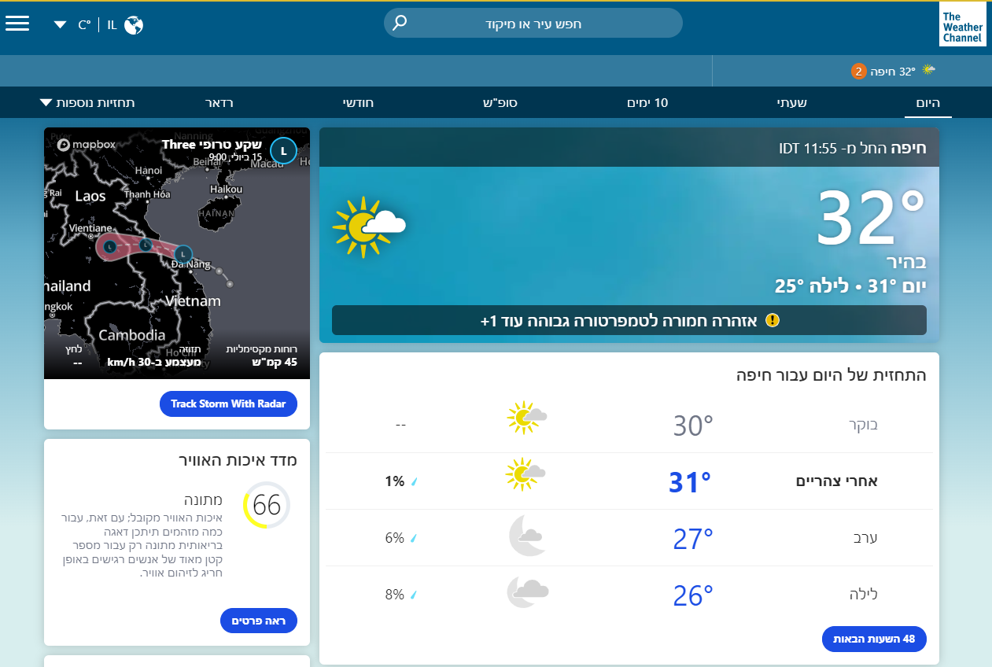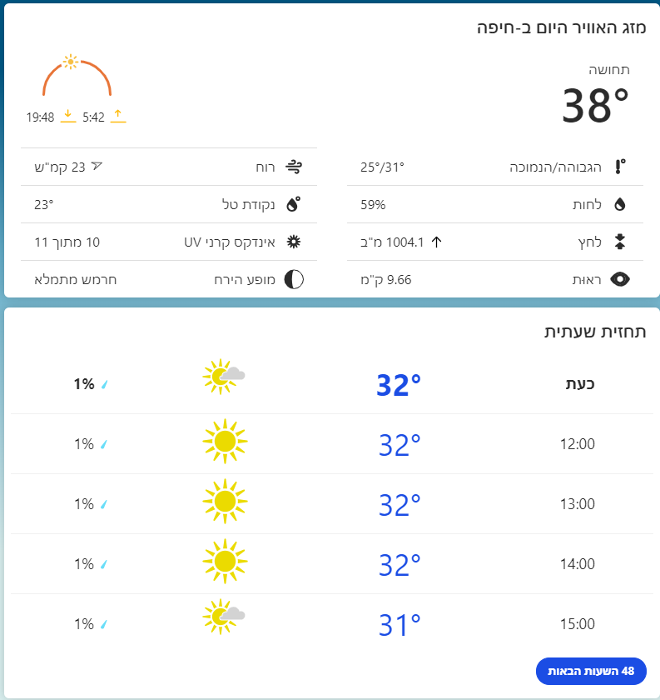  
  
  
 **2. Detailed Forecast:** This image demonstrates the detailed forecast page, where users can access comprehensive weather predictions. The hourly and daily forecasts provide insights into temperature changes, precipitation chances, and wind conditions for the coming days, allowing for better planning of activities.   
  
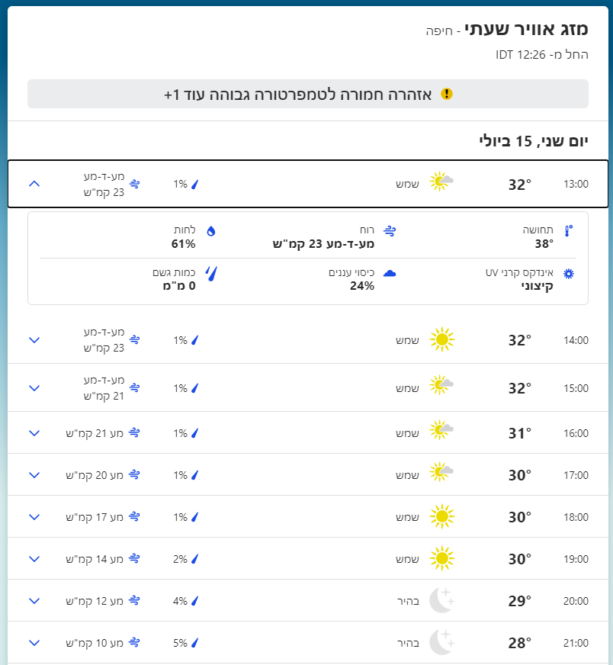  
  
**3**. **Monthly Weather Page:** This image highlights the monthly weather page, which provides users with a long-term view of weather trends.

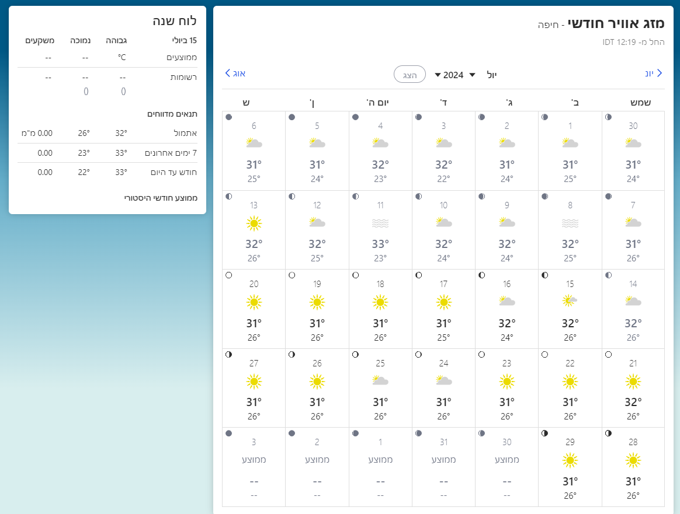

### **2.2.2 Weather25:**

**Function Details:** Weather25 specializes in providing long-range weather forecasts, focusing on 14-day forecasts with a straightforward, user-friendly interface. The platform is designed for users planning trips or events weeks in advance.

**Algorithm Details:** Weather25 uses a combination of data aggregation, statistical methods, and numerical weather prediction models to provide long-term weather forecasts.

**How it Works:** Users enter their location on the Weather25 website or app to receive 14-day weather forecasts. The platform displays weather information in an easy-to-read format, including temperature, precipitation, wind speed, and weather conditions for each day.

Existing tools for long-range weather forecasting include NWP models, statistical and seasonal models, machine learning, and reanalysis data. Each tool has its strengths and limitations, collectively contributing to a framework for improving long-range weather predictions. Advances in data processing technologies and modeling techniques present opportunities to develop enhanced software solutions, meeting the need for accurate long-range forecasts and supporting decision-making processes across various sectors.

**Examples of Features:**

* 14-day weather forecasts
* Detailed daily weather information
* Simple and intuitive user interface
* Forecasts for various locations worldwide

**Pros and Cons:** **Pros:**

1. Long-range focus: Provides weather forecasts for up to 14 days.
2. Simplicity: Easy to use and understand, suitable for general public.
3. Global coverage: Offers forecasts for numerous locations around the world.

**Cons:**

1. Limited forecast range: Only provides forecasts up to 14 days, not suitable for longer-term planning.
2. Basic features: Lacks advanced features like interactive maps or customizable alerts.
3. Requires internet access: Users need an active internet connection to access forecasts.

**Usage:**

* Popular among travellers and event planners.
* Available globally, with a significant user base in Europe and North America.

**Who is it for and under what conditions?**

* **Who:** Travelers, event planners, and general public needing mid-range weather forecasts.
* **Conditions:** Requires internet access for up-to-date forecasts.

**How many users are there?**

* Specific user numbers not publicly disclosed, but popular in Europe and North America.

**Images of The Weather25 application:**  
Long-Range Page: A screenshot of the long-range page showing historical and past weather data for a specific date.  
 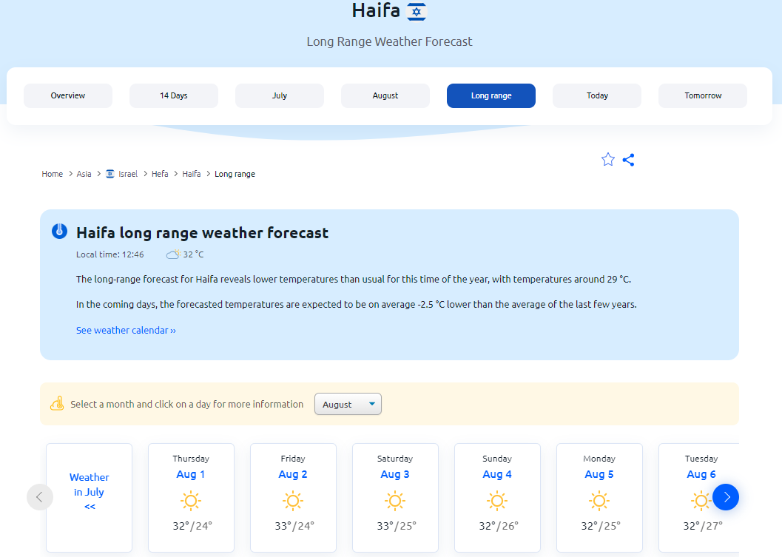Long-Range Page: This image highlights the long-range page where users can pick a month and day to view historical weather data. It shows the historical past weather for that day in Haifa and also displays the weather trends in Haifa during the last few years on that same day. This feature is beneficial for understanding weather patterns and planning based on historical trends.  
**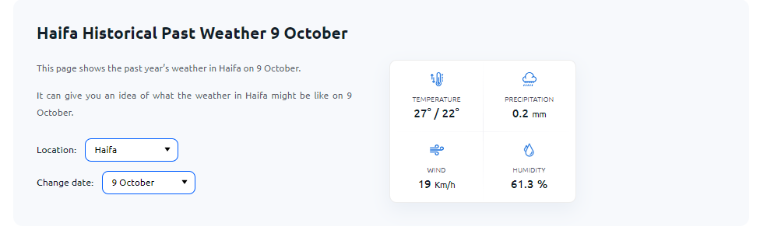  
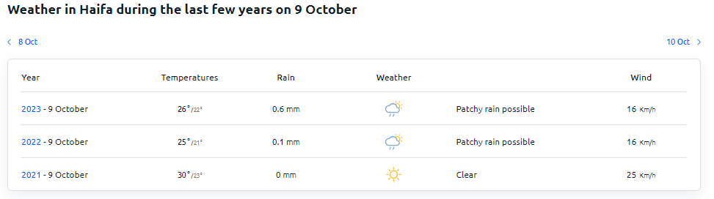**

### **2.2.3 WeatherStack**

**Function Details:** WeatherStack is a weather API service designed to provide real-time, historical, and forecast weather data. The API delivers detailed weather information, including current conditions, temperature, wind speed, humidity, precipitation, UV index, and atmospheric pressure. It supports integration into a wide range of applications, websites, and services, offering accurate and up-to-date weather information to users.

**Algorithm Details:** WeatherStack employs a combination of data aggregation, statistical analysis, and real-time data processing to deliver accurate weather information via its API.

**How it Works:** WeatherStack collects data from numerous sources, such as weather stations, satellite imagery, and radar. This data is processed through advanced algorithms to ensure accuracy and reliability. Users access the data via a RESTful API, making HTTP requests to retrieve weather information in JSON format. WeatherStack offers various subscription plans, including a free tier with limited access and premium plans that provide additional features and higher usage limits.

**Examples of Features:**

* **Real-time Weather Data:** Provides up-to-the-minute weather conditions, including temperature, wind speed, humidity, and more.
* **Historical Weather Data:** Offers access to past weather data, enabling users to analyze climate trends and historical conditions.
* **Forecast Data:** Delivers hourly, daily, and weekly weather forecasts.
* **Severe Weather Alerts:** Sends alerts and warnings for extreme weather conditions.
* **Multi-language Support:** Allows developers to create applications that cater to users in different languages.
* **Global Coverage:** Provides weather data for locations worldwide, making it suitable for global applications.

**Pros and Cons:**

**Pros:**

1. **Wide Range of Data:** Offers comprehensive real-time, historical, and forecast weather information.
2. **Easy Integration:** The RESTful API interface allows for seamless integration into various applications and services.
3. **Flexible Subscription Plans:** Offers a free tier and multiple premium plans to suit different needs.
4. **Global Coverage:** Provides weather data for locations worldwide, making it suitable for global applications.
5. **Multi-language Support:** Enables developers to create applications for diverse user bases.

**Cons:**

1. **Subscription Costs:** Premium features and higher usage limits require a paid subscription.
2. **Data Limitations:** The free tier has limited access to certain data points and lower usage limits.
3. **Requires Technical Knowledge:** API integration requires some level of programming and technical skills.
4. **Dependency on API:** Applications relying on WeatherStack may be affected by API downtime or service disruptions.

**Usage:** WeatherStack is used by developers and businesses to integrate weather data into their applications, websites, or services. It is particularly useful for industries that rely on real-time and historical weather data, such as agriculture, transportation, logistics, and event planning. Researchers and scientists also use WeatherStack for climate and weather-related studies. Additionally, hobbyists and the general public may use the API to build weather-related applications or services.

**Who is it for and under what conditions:**

* **Developers:** Looking to integrate weather data into apps, websites, or services.
* **Businesses:** In industries like agriculture, transportation, logistics, and event planning that require accurate weather data for operations.
* **Researchers and Scientists:** Conducting climate studies and atmospheric research.
* **General Public and Hobbyists:** Building weather-related applications or services.

**Conditions of Use:**

* Accessible via a RESTful API with HTTP requests.
* Free tier available with basic features; premium subscription required for additional features and higher usage limits.
* Requires internet access to retrieve weather data and updates.
* Requires technical knowledge for API integration and data processing.

**How Many Users Are There?** WeatherStack serves a wide range of users globally, including developers, businesses, and industries. While exact user numbers are not publicly disclosed, the API's widespread adoption and integration into millions of applications, websites, and services indicate a substantial user base. Its flexibility and comprehensive data offerings make it a popular choice among both large enterprises and small developers.

**Images of The WeatherStack application:**

1.Home Page for the Weatherstack API   
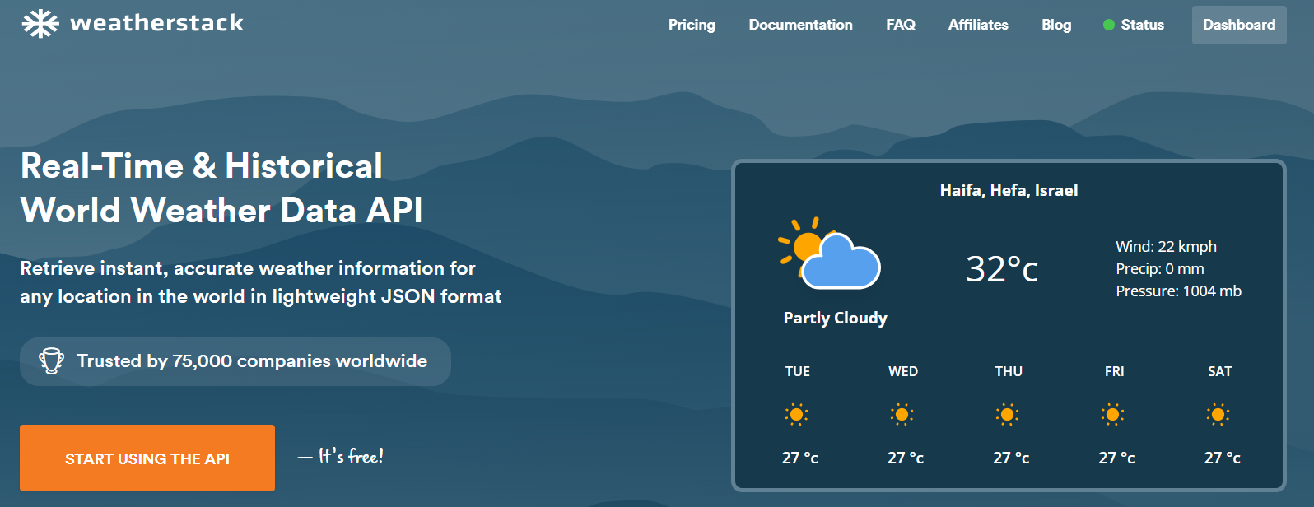2**.** API Dashboard: A screenshot of the API dashboard showing how developers can access and integrate weather data.  
 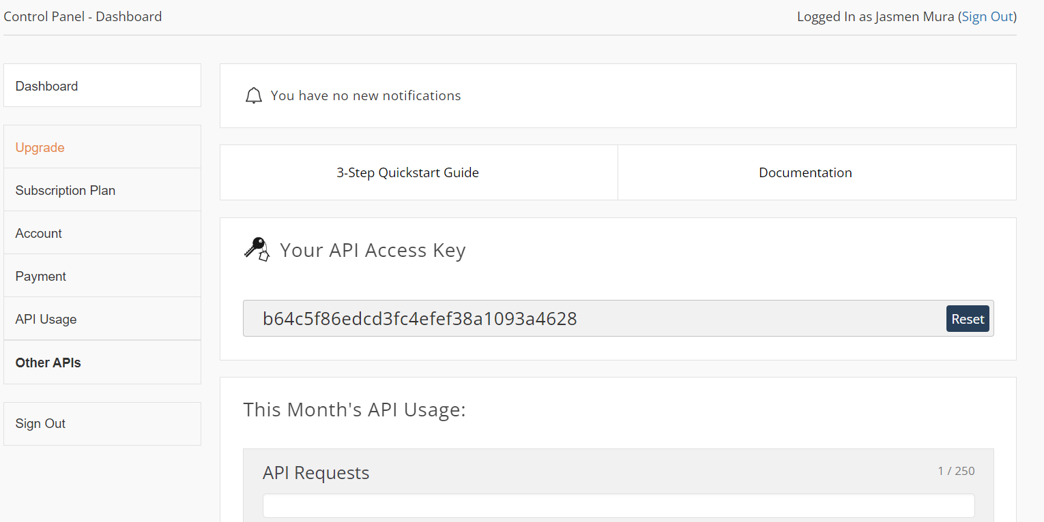3**.** Real-Time Weather Data: An image displaying real-time weather data provided by WeatherStack. 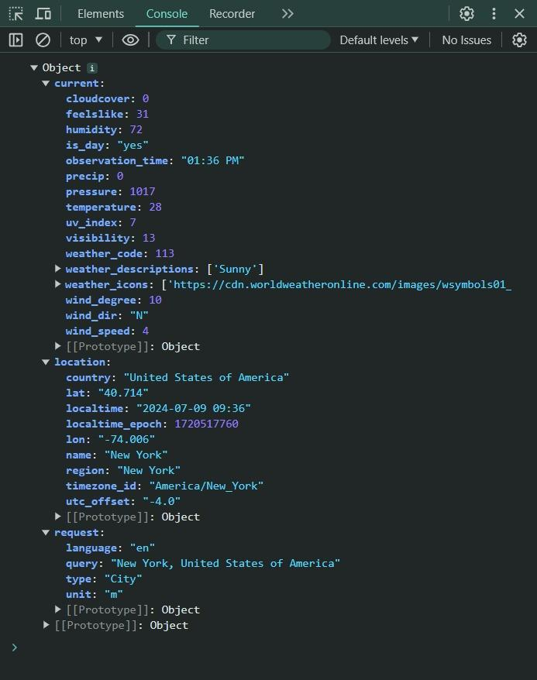

**Summary**

In the realm of long-range weather forecasting, existing tools such as Weather25, The Weather Channel, and WeatherStack provide valuable services but do not fully meet the comprehensive needs of a global audience. Weather25 offers accessible and straightforward forecasts for up to 25 days, making it popular among general users. However, its limited data sources, basic features, and reliance on advertisements can detract from the user experience and the reliability of forecasts. The Weather Channel, known for its precise and reliable forecasts, offers a wide range of features and detailed insights tailored to both individuals and businesses. Despite this, its complex interface, data overload, and subscription costs can pose challenges, especially for non-technical users. WeatherStack, a weather API service, delivers accurate weather data for integration into various applications. While it provides comprehensive real-time, historical, and forecast data, its dependency on API integration and subscription costs can limit accessibility for some users.

On a global scale, the adoption of these advanced weather forecasting tools is often limited by several factors. The detailed interfaces and complex functionalities may not be easily accessible or intuitive for all users, particularly those who are not tech-savvy. Additionally, the costs associated with premium features may deter widespread usage among the general population. Furthermore, while these tools provide valuable weather insights, they often do not fully integrate into local systems and services, limiting their effectiveness in addressing specific regional needs.

Moreover, there is a notable gap in the market for a single comprehensive weather forecasting application that combines user-friendly accessibility with high accuracy and localized insights. Such an application could significantly benefit various sectors globally, including agriculture, disaster management, energy, transportation, and everyday planning for individuals. The absence of a tailored solution that integrates advanced forecasting capabilities with an intuitive interface and local relevance leaves a significant unmet need in the global market.

### **How Our App is Different**

Our app stands out from other weather forecasting tools by using ERA5 meteorological data to provide accurate and detailed long-range forecasts. Unlike other apps that offer a single average temperature or condition, we calculate the probability of multiple possible weather scenarios. Instead of giving users just an average of what the weather might be in the long term, our app presents the probability of different temperatures and weather conditions in percentages. This allows users to see a range of possible outcomes and their likelihood, providing a deeper understanding of potential future weather patterns. By presenting probabilities instead of fixed forecasts, users can make more informed decisions, whether they're planning for agriculture, travel, or events, with a clearer view of many possible weather scenarios rather than a single estimate.

Functionality

To build a robust long-term weather prediction app, the essential functions will focus on integrating ERA5 meteorological data with advanced clustering and probability-based forecasting methods. The app provides users with probabilities of various possible weather outcomes, rather than offering a single average forecast, ensuring more comprehensive long-range weather insights.

Core functionalities will include:

* **Data Integration and Normalization:** The app processes ERA5 reanalysis data and historical weather data, ensuring consistency for accurate forecasting.
* **Clustering and Probability Forecasting:** Weather data is grouped into time windows, and clusters are formed based on historical patterns. For each cluster, the app calculates the probability of various weather conditions, offering users a range of possible outcomes rather than a single forecast.
* **Feature Extraction:** Key weather features like temperature, precipitation, and wind are analyzed to generate forecasts based on historical trends.
* **Customized Forecasts:** Users can tailor weather insights to their needs, receiving probability-based forecasts for sectors like agriculture, travel, and events.
* **Performance Monitoring:** Forecast accuracy is continuously refined by comparing real-world outcomes with predicted probabilities.

These features make our app stand out by providing users with a probabilistic view of long-term weather, helping them make better-informed decisions across various sectors.

# **3. Expected Achievements**

In developing the Long-range Weather Forecasting Project, we aim to achieve several key objectives that will significantly impact various stakeholders and improve forecasting capabilities. Below is a detailed outline of the expected achievements:

**3.1. Development of an Accurate Long-range Forecasting Model**

Objective: Develop and implement a reliable model for predicting weather conditions weeks or months in advance.

Expected Achievements:Enhanced Prediction Accuracy: Improvement in the accuracy of long-term weather predictions by integrating advanced data science techniques such as deep learning and high-resolution reanalysis data from ERA5.

Identification of Weather Patterns:Ability to detect and forecast significant weather patterns and trends over extended periods.

**3.2.Creation of a User-friendly Software Application**

Objective:Build an accessible software platform that provides long-range weather forecasts to various user groups.

Expected Achievements:Intuitive User Interface: Design a user-friendly interface that allows easy access and interpretation of weather forecasts by the general public, farmers, and planners.

Customization Features: Include features for customizing the forecast display based on user preferences, such as specific locations, time ranges, and types of weather information.

Multi-platform Accessibility: Ensure the application is accessible across multiple devices, including web, mobile, and desktop platforms.

**3.3.Integration of High-resolution ERA5 Data**

Objective:Utilize ERA5 data to provide detailed and comprehensive weather insights.

Expected Achievements:Comprehensive Data Utilization: Leverage ERA5's detailed historical and current data to enhance the accuracy and reliability of forecasts.

Advanced Analysis:Enable sophisticated analyses such as uncertainty measurements and retrospective climate assessments to support long-range forecasting.

**3.4.Provision of Valuable Insights for Decision-making**

Objective:Offer actionable weather insights that support better planning and decision-making for various sectors.

Expected Achievements:Improved Planning: Provide long-term weather forecasts that assist users in planning agricultural activities, events, and travel more effectively, reducing the impact of adverse weather conditions.

Risk Management:Enable better risk assessment and management by forecasting potential extreme weather events well in advance.

Operational Efficiency:Enhance operational efficiency in sectors like agriculture and event planning by allowing stakeholders to anticipate and adapt to weather changes.

**3.5.Support for Research and Development**

Objective:Contribute to the field of climate science and weather forecasting through innovative tools and data.

Expected Achievements:Research Advancements: Provide researchers and climate scientists with a valuable tool for analyzing long-term weather patterns and trends.

Collaboration Opportunities: Foster collaborations with academic and research institutions to further improve forecasting methodologies and climate models.

Publication and Dissemination: Facilitate the publication of findings and the dissemination of knowledge related to long-range weather forecasting and its applications.

**3.6.Market Penetration and Adoption**

Objective:Ensure widespread adoption and use of the long-range weather forecasting application.

Expected Achievements:User Base Growth:Achieve a growing user base across different segments, including individuals, farmers, event planners, and researchers.

Market Recognition: Establish the application as a trusted source for long-term weather forecasts, gaining recognition and credibility in the weather forecasting market.

Feedback Integration: Continuously gather user feedback to improve the application and add features that address emerging needs and preferences.

**3.7.Sustainable Development and Continuous Improvement**

Objective:Maintain and enhance the forecasting system over time through continuous updates and improvements.

Expected Achievements:Ongoing Updates: Regularly update the forecasting models and data sources to incorporate the latest advancements in weather prediction and data science.

Scalability: Ensure the platform is scalable to handle increasing data volumes and user demands without compromising performance.

Innovation: Continuously explore and integrate new technologies and methodologies to keep the forecasting system at the forefront of long-range weather prediction.

### 

# **4. Engineering Process**

## **4.1 Process Description and Explanation**

Our development process for the long-range weather forecasting app focuses on accuracy, reliability, and user needs. This section explains our progress so far and the next steps, along with the reasons behind our approach.

Building this app involves understanding key factors like data sources, processing power, and algorithms, while keeping in mind the needs of users in fields like agriculture, travel, and event planning. We've also looked at the limitations of current systems and how machine learning can improve accuracy and user experience.

## **4.2 Motivation and Rationale for Our Approach**

The motivation behind our approach stems from the need to address the gap in long-range weather forecasting, which goes beyond the capabilities of current short-term models. By leveraging ERA5 reanalysis data and advanced machine learning techniques, we aim to deliver accurate predictions for weeks to months in advance. This solution caters to sectors like agriculture and event planning, enhancing preparedness and decision-making processes.

##### **Work Steps and Rationale**

**Current Work Steps**:

1. **Literature Review**: We conducted a comprehensive review of the current state of long-range weather forecasting. This includes analyzing existing methodologies, technologies, and applications to identify gaps and opportunities for improvement.

* **Rationale**: This provides a foundation of existing knowledge, guiding our approach with the latest advancements and highlighting gaps we aim to address.

1. **Requirements Gathering**: We gathered key requirements through consultations with stakeholders, such as individuals from agriculture, travel agencies, and event planners.

* **Rationale**: Understanding the specific needs of our target users is crucial for developing a relevant and useful application. Engaging with stakeholders from various sectors ensures that we capture a broad set of requirements.

1. **Data Exploration**: We conducted an in-depth exploration of ERA5 reanalysis data to understand its structure, variables, and potential applications for long-range forecasting. This step was essential for assessing the feasibility and scope of our forecasting algorithms.

* **Rationale**: This allows us to identify the most relevant data for our forecasting models and assess the feasibility of our approach.

1. **Interface Design Conceptualization**: We began conceptualizing the user interface (UI), focusing on creating an intuitive and interactive platform that allows users to easily access and interpret forecast data.

* **Rationale**: A user-friendly UI is critical for user adoption and satisfaction. Early UI conceptualization ensures that the application will be intuitive and accessible for various user groups.

**Future Work Steps**:

1. **Prototype Development**: We will create functional prototypes that combine the initial UI design with core features,These prototypes will be internally tested to confirm essential functionalities and ensure they meet user needs.

* **Rationale**: Early prototyping allows for feedback collection, design validation, and iterative improvements, ensuring the final product aligns with user expectations.

1. **User Testing**: We will conduct thorough usability tests to improve the UI, focusing on making it easy to use, navigate, and ensuring the features work well for users.

* **Rationale**: Usability testing helps make sure the app meets user needs, leading to better satisfaction and more people using it.

1. **Algorithm Refinement**: We will improve our forecasting algorithms through repeated testing and validation with real-world weather data to enhance accuracy and performance.

* **Rationale**: On going refinement is key to ensuring accurate forecasts, and repeated testing will help optimize the models for better results.

1. **Integration and Scalability**: We will ensure smooth integration of all parts, including backend data processing and the frontend UI. Scalability testing will prepare the app to handle large datasets and many users.

* **Rationale**: Proper integration and scalability are essential for the app's success, ensuring it can manage big data and support a growing user base efficiently.

1. **Maintenance**: We will set up protocols for continuous monitoring, maintenance, and updates to keep the software aligned with changing weather data and user needs.

* **Rationale**: Regular maintenance is crucial to ensure the app stays relevant and performs well, adapting to new data and user demands.

Our approach is designed to address the gap in long-range weather forecasting. By using advanced data, machine learning, and focusing on user needs, we aim to build a reliable and robust application that offers valuable insights for different sectors. Each step in the process is carefully planned to ensure the creation of a high-quality, user-friendly solution while tackling the challenges and limitations of the project.

## **4.3 Constraints Affecting Our Development Process**

Several constraints have impacted the development of our long-range weather forecasting application, influencing everything from data acquisition to user adoption and technology implementation.

* **Data Availability and Quality**
  + **Data Accessibility**: The availability of ERA5 reanalysis data is crucial for our forecasting models. Any disruption in data access or limitations in the historical dataset could hinder the development of accurate forecasting algorithms.
  + **Data Quality**: The quality of the ERA5 data including its resolution, accuracy, and coverage directly impacts the reliability of our forecasts. Inconsistent or incomplete data may result in less accurate predictions, which would affect the performance of the application.
* **User Adoption and Acceptance**
  + **User Trust**: Gaining the trust of users, especially in sectors like agriculture and event planning, is essential for adoption. Addressing concerns about data privacy, forecast accuracy, and the perceived value of long-range predictions will be key to encouraging widespread use.
  + **User Experience**: The usability and accessibility of the application will play a critical role in adoption. A complex or unintuitive interface could deter users from utilizing the application, negatively impacting its overall success.

# **5. Product**

## **5.1 Algorithms Used**

Our long-range weather forecasting algorithm is built around using ERA5 reanalysis data, which provides detailed historical weather information. We leverage this data to create a time-based, probabilistic forecasting model. The approach involves dividing historical data into specific time windows, applying normalization and clustering techniques, and calculating probabilities based on the patterns observed in past weather events. This allows us to predict future weather scenarios by analyzing clusters of similar conditions.

* **K-Means Clustering:** In our project, K-Means Clustering is the core algorithm used to analyze historical weather data and generate long-range weather forecasts. This approach leverages ERA5 reanalysis data, which provides comprehensive historical weather data. The key idea behind our algorithm is to divide the historical data into time windows, group similar weather patterns using K-Means Clustering, and calculate probabilities and statistics for each cluster.

### **How We Use It in Our Algorithm in the Project:**

1. **Data Collection in Time Windows:**We start by dividing the ERA5 historical weather data into specific time windows, such as two-week periods, for each year. For each of these windows, we collect data for five years, including key weather parameters like temperature, rainfall, wind speed, and other relevant meteorological factors.

This time-windowed approach allows us to capture the variability of weather over short periods while also leveraging the wealth of data available over multiple years.

1. **Normalization Of Weather Data:** Once we have collected the data for each time window, we apply normalization to ensure all weather variables are on a comparable scale.

This is critical for clustering since variables with different ranges (e.g., temperature in degrees versus wind speed in meters per second) could disproportionately affect the results if not properly scaled.  
Normalization ensures that each weather variable whether it's temperature, precipitation, or wind speed contributes equally to the clustering process.

1. **Clustering Weather Data:** After normalization, we apply the K-Means Clustering algorithm to group the weather data from different time windows into distinct clusters. Each cluster represents a set of similar weather patterns, such as periods of hot and dry weather or cold and wet conditions.

For example, during a specific two-week period over five years, we may group weather data into clusters where each cluster reflects different but recurring weather patterns, such as frequent rains or heatwaves.

The number of clusters (k) is chosen carefully where we analyze how the variance within clusters decreases as k increases. This helps us balance model complexity and interpretability.

1. **Calculating Probabilities for Each Cluster :**For each new set of weather data in a given time window, we calculate the probability of that data belonging to each cluster. This is done by measuring how close the new data is to the centroid (center) of each cluster, using Euclidean distance.

The result is a probabilistic forecast rather than predicting a single weather outcome, we provide multiple possible outcomes based on which clusters the new data is most likely to belong to. For example, if the current weather conditions closely resemble a cluster that historically led to heavy rain, the algorithm will assign a high probability to rain.

1. **Average and Standard Deviation Calculation:** Once the clusters are formed, we calculate the average values of weather parameters (e.g., temperature, rainfall) within each cluster.This gives a representative “profile” of the weather for each cluster. Additionally, we compute the standard deviation for each cluster, which measures the variability of the weather conditions within that cluster. This is important because it helps us understand the range of possible outcomes for a given cluster. For example, a cluster with high variability might indicate that the weather in that time window can fluctuate more widely, providing insights into the uncertainty of the forecast.

### **Why It’s Useful for Our Weather Forecasting Project:**

* **Recognizing Historical Patterns:** K-Means clustering allows us to effectively group similar weather patterns from the ERA5 historical dataset. By analyzing these recurring patterns, we can build a strong foundation for predicting future weather based on past behavior. The ability to cluster similar weather conditions across years helps us capture long-term trends that are critical for accurate long-range forecasting.
* **Probabilistic Forecasting:** One of the key benefits of using K-Means in our project is that it enables probabilistic forecasting. Instead of giving a single forecast, we provide users with multiple possible weather outcomes and the likelihood of each scenario. This offers a more nuanced view of future weather conditions and allows for better decision-making in sectors such as agriculture, travel, and event planning, where preparation for different weather outcomes is essential.
* **Efficiency in Large Datasets:** Given the vast amount of historical data in the ERA5 dataset, K-Means is computationally efficient and scales well. It allows us to process large datasets and deliver reliable forecasts in a timely manner. This is critical for real-time applications where weather data is continuously updated and predictions need to be quickly generated.

## **5.2 Models Developed**

The application’s core functionality is built around models designed to process and display weather data in a user-friendly manner while leveraging K-Means clustering to improve predictions based on historical patterns from ERA5 data.

* **Data Ingestion and Preprocessing:** T This model is responsible for collecting historical weather data in predefined time windows (e.g., two-week periods) from the ERA5 reanalysis dataset. The model normalizes the weather parameters (e.g., temperature, rainfall, wind) to ensure that they are on comparable scales before being clustered.
  + **Rationale:** This preprocessing step is essential for ensuring that weather data is structured, cleaned, and ready for use in the clustering and prediction models, thus improving the reliability of forecasts.
* **Forecasting Model:** The forecasting model uses K-Means clustering to group historical weather data into clusters based on similarities in weather conditions over defined time periods. For each new weather observation, the model calculates the probability that the data belongs to one of the historical clusters. Predictions are provided for variables like temperature, probability of rain, and cloud cover by comparing the current data to the identified clusters and their historical outcomes.
  + **Rationale:** By leveraging clustering, this model allows the application to provide forecasts that are not only accurate but also based on historical trends, enhancing the overall reliability of the predictions.
* **Cluster Analysis Model:** In this model, historical weather data is segmented into clusters based on weather conditions like temperature, cloud cover, and precipitation probabilities. The application uses these clusters to identify the most similar past weather patterns to current conditions, offering insights into the likelihood of various weather outcomes.
  + **Rationale**: Cluster analysis allows for a deeper understanding of how current weather conditions relate to past trends, improving forecast accuracy by contextualizing the predictions with historical data.

## **5.3 Requirements**

**Functional:**

| 1 | The system allows automatic retrieval and display of the current week’s weather forecast when the application starts, based on the user's location |
| --- | --- |
| 2 | The system allows manual input of location and validates it. |
| 3 | The system allows users to select a location from a map and converts the selection into geographic coordinates. |
| 4 | The system allows users to input and validate a specific date or date range for weather forecasting. |
| 5 | The system allows the retrieval of relevant weather data from the ERA5 dataset based on the specified location and date range. |
| 6 | The system allows the application of clustering techniques to historical weather data to generate long-range forecasts. |

**Non-Functional:**

| 1 | The interface must be intuitive and user-friendly, allowing users to easily navigate through features such as location selection, date range, and forecast viewing. |
| --- | --- |
| 2 | The application must be responsive on various devices and platforms, ensuring that users can access the forecasts on different screen sizes without any issues. |
| 3 | The system should be easy to maintain, allowing for updates to the forecasting models and interface as new features or data become available. |
| 4 | The system must be highly reliable, ensuring weather forecasts are available at all times. |

**5.4 System Functionality**Our weather forecasting application offers a comprehensive set of features designed to provide users with accurate and easy-to-understand long-range weather predictions. The application ensures seamless integration of weather data, allowing users to select locations either manually or through an interactive map, view current and long-range weather forecasts, and compare forecasts with historical weather patterns. The system automatically retrieves the current week's forecast upon opening the app, processes user inputs for specific locations and dates, and delivers real-time weather updates in an intuitive interface.

Additionally, the system is optimized for handling large datasets from ERA5, ensuring fast data retrieval and processing without compromising performance. The application’s real-time data display allows users to see weather metrics such as temperature, rain probability, cloud coverage, and wind speed, presented with easy-to-understand visualizations. Users can also access historical weather clusters to compare past patterns with current conditions, further enhancing the decision-making process.

With these robust features, the application is designed to meet the needs of users seeking reliable and long-range weather forecasts for planning and decision-making purposes. For a detailed overview of the system's functionalities, please refer to Tables 6.3.1 – 6.3.3.

### **Table 5.4.1 - System Functionalities:**

| Functionality | Description |
| --- | --- |
| AutomaticWeather Display | Automatically retrieves and displays the current week’s weather forecast when the app is opened. |
| Location Input (Manual) | Allows users to manually input their location for forecast retrieval. |
| LocationSelection (Map) | Allows users to select a location from an interactive map. |
| Date Selection | Enables users to choose a specific date or date range for long-range forecasts. |
| Historical Weather Comparison | Displays historical weather clusters for users to compare past and current weather patterns. |
| Data Retrieval | Retrieves weather data from the ERA5 dataset based on the user’s location and date selection. |
| Weather Metrics Display | Displays key weather metrics such as temperature, rain probability, cloud coverage, and wind speed. |

### **Table 5.4.2 - User Interaction Functionalities:**

| Functionality | Description |
| --- | --- |
| Interactive Map | Allows users to interact with the map to select their forecast location. |
| Weather Data Visualization | Presents forecast data in graphical formats (charts, tables) for ease of understanding. |
| Real-Time Input Validation | Ensures that user inputs (location, date) are valid and processes correct data for forecasting. |

## **5.5 Diagrams**

### **5.5.1 Use Case Diagram**

### **5.5.2 Activity diagram**

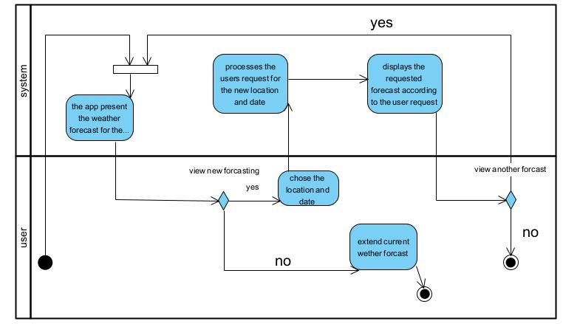

# **6. Tests**

This project’s testing focuses on verifying key functionalities of the weather forecasting application, including data processing, user interface behavior, and forecast accuracy. The following table outlines test cases to ensure that the system handles location input, clustering, and data normalization correctly, while providing an intuitive and responsive user experience. These tests will help identify any issues early, ensuring the application delivers accurate and reliable weather forecasts.

#### 

| **Test Case ID** | **Test Case Description** | **Input** | **Expected Output** |
| --- | --- | --- | --- |
| 1 | Test location input (map selection) | User selects a location on the map | Application should accurately identify the location |
| 2 | Test location input (manual entry) | User manually types in a city/country | Application should recognize and display the location |
| 3 | Test current weather forecast display | User opens the app | Display current week’s weather forecast |
| 4 | Test long-range forecast calculation | User requests a forecast for two weeks ahead | Application provides weather probabilities and scenarios based on clustering |
| 5 | Test cluster probability calculation | Historical weather data | Correct probabilities of being in a cluster |
| 6 | Test responsiveness on mobile devices | App opened on various screen sizes | UI should adjust and display correctly |
| 7 | Test user interface (layout/navigation) | User interacts with forecast screen elements | Easy navigation and readability of weather forecast |
| 8 | Test data refresh on new forecast | User requests new forecast for a different time frame | Application updates forecast data accordingly |
| 9 | Test error handling for invalid input | Invalid location or data input | Display appropriate error message |

# **7. GUI**

Welcome to the Home Page, where you can begin your own weather forecast journey. On this screen, you can choose the location you'd like to check the weather for.

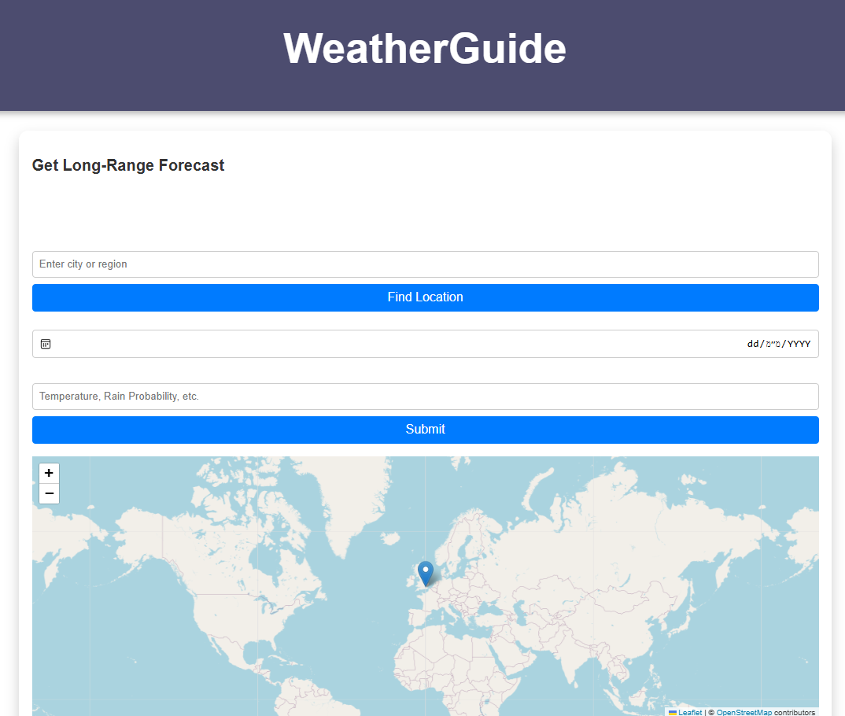

On this page, there are two ways to select a location for your weather search: you can either choose from a map or enter the name of the place manually.

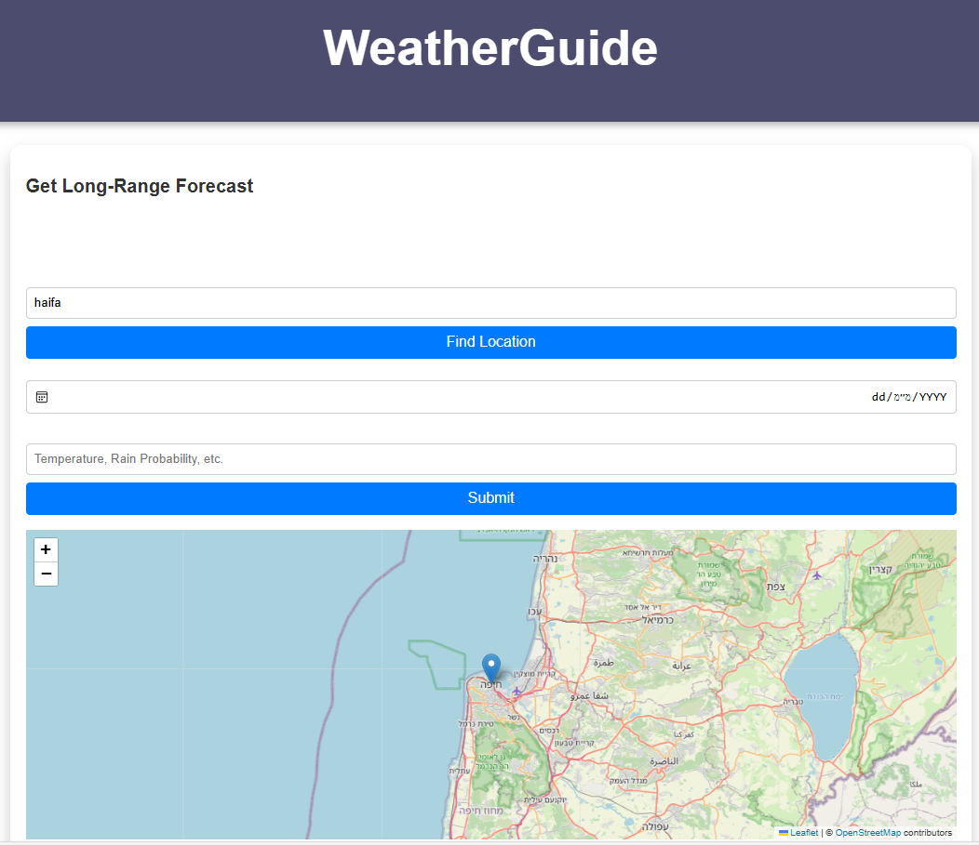

The result on this page will show the weather forecast for the selected location, divided into three clusters. Each cluster will display information about temperature, rain, and wind conditions.

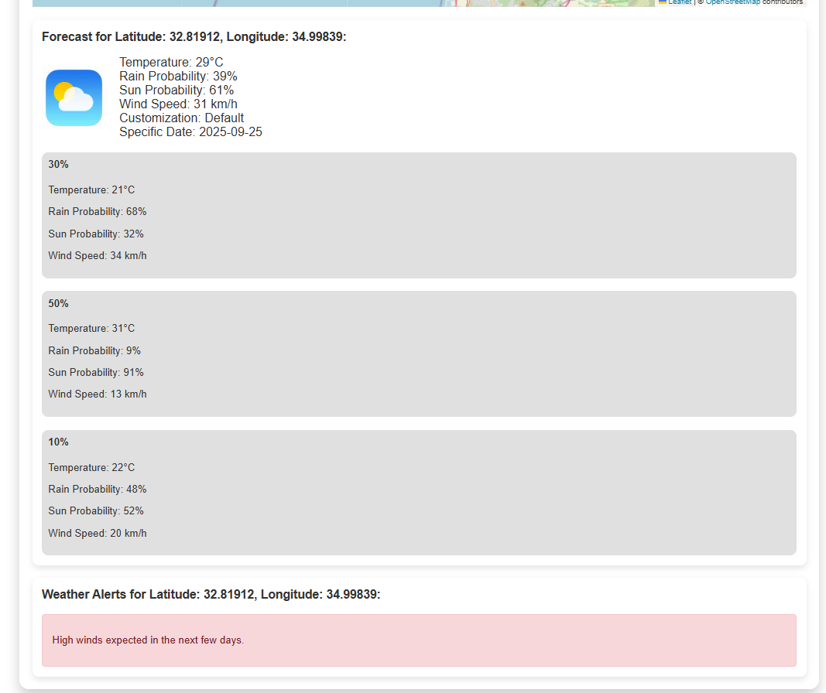

# **8. References**

1. **Numerical Weather and Climate Prediction** by Thomas Tomkins Warner. This book covers the fundamentals of NWP and discusses various aspects of model accuracy and limitations.

2. **An Introduction to Dynamic Meteorology** by James R. Holton and Gregory J. Hakim. This textbook explains the mathematical and physical basis of NWP models and their applications in weather forecasting.

3. **Review Article: The Impact of Global Models on Weather Prediction** by Eugenia Kalnay, Bulletin of the American Meteorological Society. This article provides a comprehensive review of NWP models and their development over the years.

4. **Accuracy and Limitations of Numerical Weather Prediction** by Roger Daley. In this article, the author discusses the various factors affecting the accuracy of NWP models.

5. **Understanding Numerical Weather Prediction Models** by the National Weather Service. This online resource offers an overview of NWP models and explains their role in weather forecasting.

6. "ERA5: Data documentation" – Copernicus Climate Change Service.  
https://cds.climate.copernicus.eu/cdsapp#!/dataset/reanalysis-era5-single-levels?tab=overview

7. "Advantages of Long-range Weather Forecasting" – Various scientific journals and articles on long-range weather prediction methodologies.

8. "WeatherStack API Documentation" – WeatherStack..